# Homework: Bugs and Bug Tracking

## Bug Hunting: Google Home Page

|  |  |
| --- | --- |
| **Bug** | **Description** |
| **Bug #1** | Logo: “g” and “l” are in the wrong colors. |
| **Bug #2** | “Gmail” link is not properly aligned. |
| **Bug #3** | “Google apps” icon is not visualized correctly – 8 instead of 9 dots. |
| **Bug #4** | Magnifying glass icon is not visualized correctly – mirrored icon direction. |
| **Bug #5** | “Search by voice” icon is not in the correct visual design – wrong shape and colors. |
| **Bug #6** | “Search by image” icon is missing from the search field box. |
| **Bug #7** | Typo on the “I’m Feeling Lucky” button: feeling is misspelled. |
| **Bug #8** | Detected location name of Bulgaria is displayed in a wrong text font. |
| **Bug #9** | “Advertising” section link is missing in the footer. |
| **Bug #10** | “Business” section link is missing in the footer. |
| **Bug #11** | “Privacy” section link is missing in the footer. |
| **Bug #12** | “How Search works” section link is duplicated in the footer. |
| **Bug #13** | There is no page name and page fav icon on the tab of the browser. |

## Bug Hunting: Notepad Application

|  |  |
| --- | --- |
| **Bug** | **Description** |
| **Bug #1** | New Document Name missing in the header. “Untitled” should appear if no custom name is entered. |
| **Bug #2** | “Format” menu section is wrong. Should be “View”. |
| **Bug #3** | The app icon is not the correct design and color. |
| **Bug #4** | Horizontal and vertical sliders should not be visible on an empty document. |
| **Bug #5** | Horizontal slider’s right arrow is in the wrong color – red instead of default color. |
| **Bug #6** | Settings wheel button is missing. |
| **Bug #7** | “Restore” button is missing from the header. |
| **Bug #8** | “Minimize” button is missing from the header. |
| **Bug #9** | “X” button for closing the app is displayed in a wrong format/font. |
| **Bug #10** | On the File menu option “Exit” is missing. |
| **Bug #11** | On the File menu option “Open…” the name is incorrect. Should be “Open”. |
| **Bug #12** | On the File menu option “Open…” the keyboard shortcut command is missing. Should be “Ctrl+O”. |
| **Bug #13** | On the File menu option “Page Setup…” the name is incorrect. Should be “Page Setup”. |
| **Bug #14** | On the File menu option “Print …” the name is incorrect. Should be “Print”. |
| **Bug #15** | On the File menu option “Print …” the keyboard shortcut command is missing. Should be “Ctrl+P”. |
| **Bug #16** | On the File menu all keyboard shortcuts are aligned to the right, instead to the left. |

## Bug Reporting: Gmail

|  |  |
| --- | --- |
| **Bug ID** | BBT-2 |
| **Priority** | Medium |
| **Severity** | … |
| **Assigned to** | Unassigned |
| **Reported by** | Emiliya Kirina |
| **Reported on** | 20.02.2023 |
| **Status** | To-do |
| **Environment** | Microsoft Windows 11 Home Version 10.0.22621 Build 22621; Mozilla Firefox 109.0 (64-bit) |
| **Summary** | Wrong redirect on Gmail log-in. |
| **Description** | I am not able to see my Inbox when signed in to Gmail. |
| **Expected behavior** | When I log into Gmail I can see my Inbox and all messages. |
| **Actual behavior** | When I log into Gmail I am redirected to Google.com page. |
| **Steps to reproduce** | 1. Open gmail.com. 2. Fill in username and password. 3. Click the “Sign in” button. 4. Wait to be redirected. 5. See the result. |

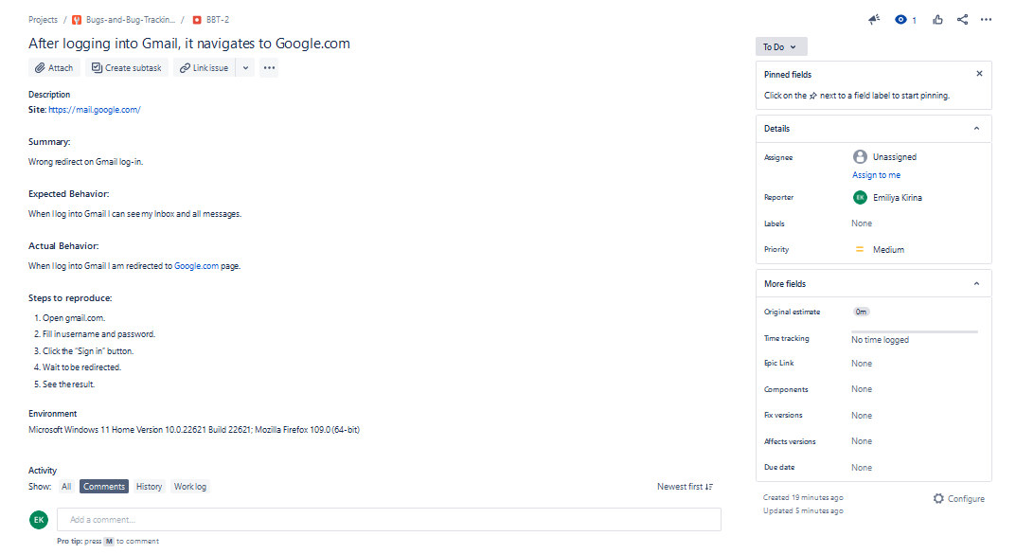

## Bug Reporting: Reset Password

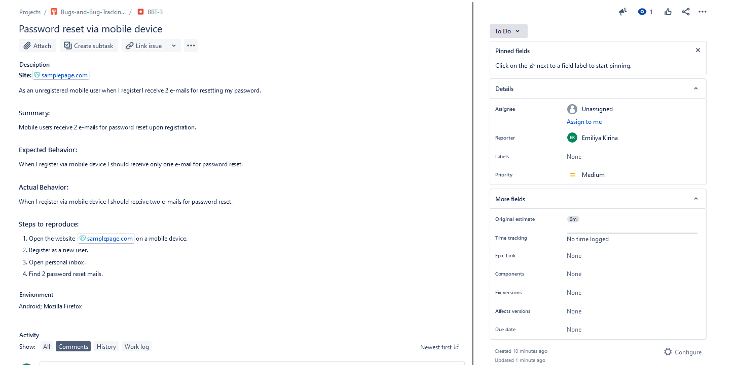

## Register in Atlassian Jira Cloud

<https://softuni-qa-exercises.atlassian.net/jira/people/63c7f312b1262586707a8534>

## Bug Reporting: Registration Form

Report all bugs found in your Jira project.  
Optionally you may also describe bugs in the table below or **attach** **screenshots.**

|  |  |
| --- | --- |
| **Bug** | **Description** |
| **Bug #1** |  |
| **Bug #2** |  |
| **Bug #3** |  |
| **Bug #4** |  |
| **Bug #5** |  |
| **Bug #6** |  |
| **Bug #7** |  |